|  |  |  |
| --- | --- | --- |
| **Report IDM reference No.** | EFDA_D_2NGHCF | **Version: see IDM** |

Final Report

on Deliverable

MAT-1.4.2-T3-D1 Summary overview document on Organization and Implementation of EDDI Testing Plan for 2016 (ENEA-CNR)

|  |  |  |  |
| --- | --- | --- | --- |
|  | | **Deliverable-ID**[1] | *MAT-1.4.2-T3-D1* |
| **Work Package** | *WPMAT* | **Date** | *31 Oct 2016* |
| **Project Leader** | *Michael Rieth* | | |
|  | | | |
| **TS Title** | Implementation of EDDI Testing Plan for 2016 | | |
| **TS Ref. No.** | *MAT-1.4.2-T003* | **TS IDM-link** | [*2MLX3K*](https://idm.euro-fusion.org/?uid=2MB5X5) |
| **Task Owner** | *Enrico Perelli Cippo* | | |
| **RU(s)** | *ENEA-CNR* | | |

|  |  |
| --- | --- |
| **Report Review & Approval** | |
| **IDM role** | **Name(s)** |
| **Author** | *E. Perelli Cippo* |
| **Co-author(s)** | *G. Angella, R. Donnini* |
| **Reviewer(s)** | *Michael Gorley,* |
| **PMU Reviewer** | *Eberhard Diegele* |
| **Approver** | *Michael Rieth* |

|  |  |  |  |  |  |
| --- | --- | --- | --- | --- | --- |
| X | Study / Assessment |  | Procurement / Commissioning of Hardware |  | Industry |

|  |  |  |  |
| --- | --- | --- | --- |
|  | Use of Facility |  | Other *{please specify}* |

|  |
| --- |
| **Executive Summary** |
| As planned in the previous year, EDDI testing plan started with a *round robin* test campaign on EUROFER 97. The campaign of TENSILE testing was completed, with some delays, in Oct. 2016, and the data was discussed just after such term.  The first real data requests have been presented during 2016, and namely creep tests on pre-fatigued specimens, LCF tests and fracture tests with a non-standard yoke/pin configuration.  The real tests required have been prioritized and started in 2016. They will continue in 2017 with other tests (especially LCF) to be distributed to the different RUs following cost exigencies and results of the RR. |

|  |
| --- |
| **Comments** (shortcomings, deviations, etc.) |
| Some lack of communication was experienced also during the RR campaign, especially about the details of the conditions explicitly requested for the tests. This suggested to review the test request templates in order to avoid confusion. |

**Table of Contents**

1 Objectives of Work 2

2 Round Robin test campaign 3

2.1 General **3**

2.2 Tensile tests **5**

2.3 Round Robin Fracture Toughness campaign **5**

2.4 Round Robin Low Cycle Fatigue campaign **6**

3 “Real” samples testing 6

3.1 General **6**

3.2 Creep tests on pre-fatigued specimens **7**

**4 Deviations from the previous year plan ....................................................................................9**

**5 Testing plan for 2017 ......................................................................................................................10**

**6 Conclusions and remarks ................................................................................................................11**

**Abbreviations**

|  |  |
| --- | --- |
| *ALARA* | *As Low As Reasonably Achievable* |
| *BoP* | *Balance of Plant* |
| *BU* | *Breeder Unit (Blanket)* |
| *CCFE* | *Culham Centre for Fusion Energy, Great Britain (formerly UKAEA)* |
| *EDDI* | *Engineering Data and Design Integration* |
| *RU* | *Research Units* |
| *RR* | *Round Robin (description …)* |
| *UTS* | *Ultimate Tensile Strength* |
| *LCF* | *Low Cycle Fatigue* |
|  |  |

# Objectives of Work

This report has the objective of overviewing the EDDI testing planof 2016:

(i) the organization and performing of the *Round Robin* (RR) campaigns of different mechanical testing started in 2015;

(ii) the performing of the first “real” (i.e. non RR) tests.

# Round Robin test campaign

## General

It had been agreed that a *RR test campaigns different mechanical testing* had to be performed in 2015 to check homogeneity of results and data produced by the different RUs, and to check also the good operation of the EDDI test request-test performing interface. EUROFER 97 was chosen as the representative material for the RR campaigns. A batch of material was made available by KIT for this purpose. The first stage of the RR campaigns is focused only on three kinds of tests: *tensile* tests, *low cycle fatigue* (LCF) tests and *fracture toughness* tests. A total of seven RUs (NRG volunteered for participating in RR during 2016) agreed to participate to the RR campaigns for at least a kind of mechanical test. Table 1 in the *MAT-1.4.2-T2-D1 Summary overview document on Implementation of EDDI Testing Plan for 2015* shows the RUs that offered to perform RR tests and the kind of tests originally agreed.

However, there has been a deviation from this original scheme: the conditions normally used by UPM for LCF tests were considered, after discussions, very different to the ones used by all the other RUs; for this reason, UPM did not participate to the LCF RR campaign.

KIT provided the material for the different tests to the RUs that agreed to the RR, and namely:

* the samples for the *tensile* and *fracture toughness* tests have been provided as batches of EUROFER 97 steel, cut and heat treated by KIT; the single specimens have been machined by the different RUs accordingly to their own standards.
* the samples for LCF tests have been provided by KIT in the form of final specimens, prepared accordingly to the specifications contained in the test requests and to the drawings provided by the different RUs attending RR.

The difference in the two approaches is due to the fact that complete uniformity of specimen fabrication and surface finishing is considered paramount for LCF testing.

Due to the nature of the RR, maximum possible freedom has been granted to the different RUs in performing their tests. Except the given test parameters, all RUs have used their own commonly used equipments, as per their common practice.

For the same reason, a RR-specific set of test requests (somehow simplified respect to the standard *Test Specification Template* (EFDA D 2MH8AG: [*https://idm.euro-fusion.org/?uid=2M6428*](https://idm.euro-fusion.org/?uid=2M6428)) was prepared and presented to the different RUs to assess their capability to attend the RR campaign.

Some RUs could not perform the tests in due time; for this reason, the deadline for the provision of results was shifted in some occasions, and it was necessary to set a strict deadline for the provision of datasets at the end of this year. It was felt necessary to underline that, after the mentioned deadlines, if a RU has not started the tests yet, it will be required to send back the specimens/material batches it was provided.

The situation of the RR test campaign, at the date of the preparation of this draft is presented in Table 1. The color code adopted is just a guide for the eye and it does only reflect expected delays.

|  |  |  |  |
| --- | --- | --- | --- |
| Table 1: status of the RR test campaign (Oct. 2016) | | | |
| **RU** | **Tests** | **Status** | **Expected date/problems** |
| CIEMAT | Tensile + LCF | Tensile: **completed** | LCF: **expected to start after tensile tests** |
| SCK-CEN | LCF |  | LCF tests will start in Nov./Dec. 2016 |
| KIT | Tensile + LCF + Fracture | Tensile: **completed**  Fracture: a single test (300°C) was not possible; **otherwise completed** | LCF: tests will start in Oct. 2016 |
| ENEA-CNR | Tensile + LCF | Tensile: **completed** | LCF: tests ongoing |
| NRG | Tensile + LCF + Fracture | Tensile: **completed** | Fracture: specimens pre-cracked but **test delays expected**  LCF: ongoing |
| MTA-HAS | Tensile + Fracture | Tensile: **completed** | Fracture: **performed but problems emerged** |
| UPM | Tensile (*LCF conditions were considered not compatible with other RUs)* | Tensile: **completed** |  |

## Tensile tests

The tensile testing campaign was completed in October 2016.

However, some problems emerged after the organization of the RR testing, also due to a lack of communications between RUs. Some RUs misunderstood the requests into the test specification requests. In particular, at least one RU (NRG) performed most tensile tests without online extensometers control, as it was requested, but operated the tests in “stroke control” mode. However, this approach does not allow a precise characterization of the elastic part of the stress – strain tensile curve, and in particular does not allow the estimation of the Young modulus (*E*). For this reason, such a RU could not provide the estimation of *E*, although it was requested. The other requested parameters, however, were provided.

In another case, one RU could not perform the tests.

The data provided for the tensile campaign have been discussed during a VC meeting set on 30/09/2016. Unfortunately, no representative from the UPM RU could attend the meeting (despite this RU had participated to the campaign and provided the data in due time). In the discussion, it emerged that most of the data are compatible in terms of estimated parameters (Young modules, UTS etc.) with the exception of UPM where the results were significantly different from other RU and out of anticipates specifications (see Appendix A for details) .

## Round Robin Fracture Toughness campaign

Only three RUs agreed to complete the fracture test campaign.

In general, the campaign was retarded respect to the tensile campaign, and at the time of preparation of this draft, two sets of data have been received (see Table 1). The fracture tests by CIEMAT are scheduled to start in Oct./Nov. 2016.

A discussion about the datasets will be held as soon as all the datasets will be made available.

## Round Robin Low Cycle Fatigue campaign

Five RUs agreed to participate to the LCF. However, the testing conditions offered by one RU (and namely the available specimens dimensions) were not considered compatible with the ones of other RUs, thus it was excluded from this RR.

Despite the specimens were provided by KIT in due time, there was a general delay of this kind of tests, and most RU are expected to perform the tests at the end of 2016.

The results will be discussed, as for the other two kinds of tests, as soon as all the datasets will be received.

# “Real” samples testing

## General

Until now, two requests have arrived to EDDI of testing of “real” (*i.e.* non RR), and namely:

* By J. Aktaa (KIT) a series of test requests have been presented about creep tests on pre-fatigued samples, both to be performed on EUROFER97/2 steel. The creep tests on pre-fatigued specimens have been started at the beginning of October 2016 (pre-fatigue tests were finished on July 2016).
* By M. Fursdon (CCFE) series of tests to assess a new method to estimate fatigue life based on fracture mechanics. This request is part of the study to develop new design rules for DEMO.

It was decided that the tests proposed by Jarir Aktaa (KIT) will be performed at ENEA-CNR, while the tests proposed by Michael Fursdon (CCFE) will be performed at KIT.

## Creep tests on pre-fatigued specimens

A campaign of creep tests on pre-fatigued EUROFER97/2 specimens is running in the Mechanical Characterization Lab in the CNR-ICMATE (ex IENI). Ten tests have been requested by Prof. Jarir Aktaa from KIT ([(EFDA_D_2LJDNQ v1.1)](https://idm.euro-fusion.org/?uid=2LJDNQ&action=get_document)). The requested conditions are:

1. Two different pre-fatigue testing conditions:
   1. Condition Nr 1 for 5 LCF specimens in EUROFER97/2:
      1. Temperature = 550°C;
      2. Cycle shape = triangular;
      3. Strain rate = 10-3 s-1;
      4. Strain range = 1.0%;
      5. Cycle number = 250.
   2. Condition Nr 2 for 5 LCF specimens in EUROFER97/2:
      1. Temperature = 550°C;
      2. Cycle shape = triangular;
      3. Strain rate = 10-3 s-1;
      4. Strain range = 0.4%;
      5. Cycle number = 2500.
2. For each pre-fatigue condition there are five different creep testing conditions:
   1. On the 5 specimens pre-fatigued according to condition Nr 1, creep tests at 550°C have to be performed with the following initial loads:
      1. 240 MPa;
      2. 220 MPa;
      3. 200 MPa;
      4. 180 MPa;
      5. 160 MPa.
   2. On the 5 specimens pre-fatigued according to condition Nr 2, creep tests at 550°C have to be performed with the following initial loads:
      1. 240 MPa;
      2. 220 MPa;
      3. 200 MPa;
      4. 180 MPa;
      5. 160 MPa.

The material was received in May 2016 in the form of a piece of rolling slab, heat treated in KIT. The 10 LCF specimens (gauge diameter = 6 mm; gauge length = 18 mm) were machined by a local firm (R4T *SpA*) according to the LCF drawing complying the ASTM E606. After LCF tests the pre-fatigued specimens were sent to the same local firm to machine off the creep specimens. The geometry of the creep specimen was modified to meet the geometry of the pre-fatigued specimen, so the creep specimen gauge was actually machined off from the gauge of pre-fatigued EUROFER97/2. The resulting creep specimen gauge dimensions were diameter = 3.60 mm and gauge length = 18.00 mm, to comply to the ASTM E8/E8M-11. In Fig. 1 a picture of a LCF specimen and a modified creep specimen is reported.

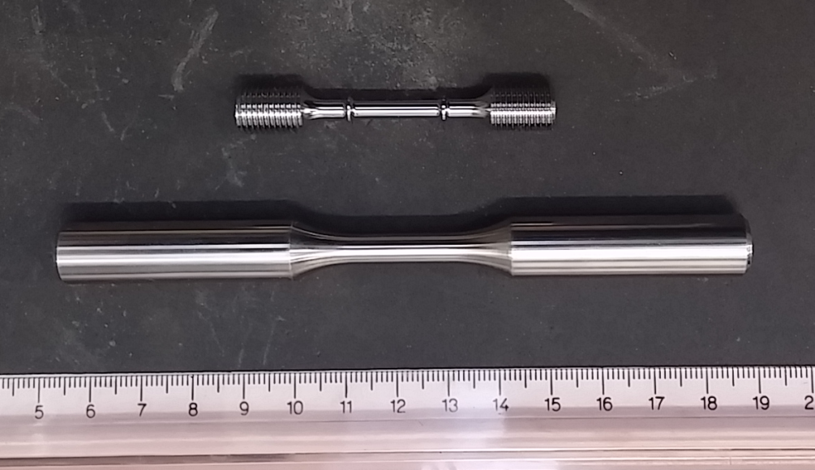

*Fig. 1: LCF specimen (below) complying to ASTM E606 and creep specimen (above) complying ASTM E8/E8M-11.*

The 10 LCF tests with pre-fatigue conditions No. 1 and 2 were performed on the universal testing machine MTS 312.21 with induction heating system.

Two creep testing rigs are working on the creep campaign: a conventional creep testing rig with three-zone furnace (in-house code = M); and a universal mechanical testing rig DMG with three-zone furnace (in-house code = I).

At the time of the preparation of this draft, three creep tests are completed and 2 other tests are running. The actual progress of the testing campaign is reported in Fig. 2.

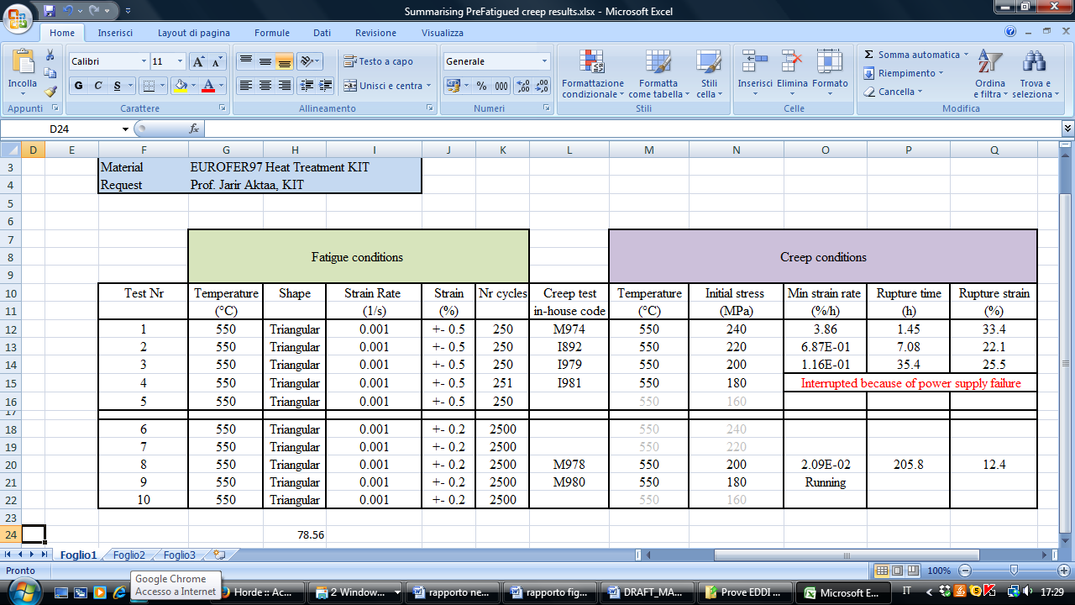

*Fig. 2: Progress of the testing campaign: creep tests on pre-fatigued EUROFER97/2.*

# Deviations from the previous year plan

The whole testing plan experienced a general delay.

For what is concerning the fracture data, at the time of the preparation of this report (Oct. 2016), not all the datasets have been provided, although the tests themselves have already started (see Table 2). At least one of the RUs that agreed to perform the fracture tests has foreseen delays that will last until next year. Moreover, another RU experienced problems with the tests and it may be possible that further tests will be required to asses them. Considering the time necessary to discuss the data once received, it is reasonable to expect that the whole campaign will be reasonably concluded not before the first two months of 2017 (see Table 3).

For what is concerning the LCF campaign, all the specimens have been provided by KIT in due time (following the previous year plan). However, these tests also experienced some delays. At the time of the preparation of this report (Oct. 2016), all but two RUs have started the first LCF tests; the other two plan to start the first tests before the end of 2016. Thus, for the same reasons expressed for fracture tests, the whole campaign will end in the very first part of 2017.

As it was made for the tensile campaign, the data obtained during the RR campaigns will not be directly passed to the Database personnel. However, specific *RR-meetings* will be organized (care of ENEA-CNR RU) in order to discuss and review the data. Main concerns of such a meeting will be:

a) identifying possible outliers in the data;

b) verifying the data scatter;

c) suggesting possible improvements to limit the data scatter (if this is the case).

The meeting will be mandatory for all the RUs involved in the RR campaign and representatives from the Database groups, but it will be open also to other representatives from EDDI and/or WPMAT. The meeting should be organized no later than April 2017, and in any case well before the mid-year monitoring meeting.

# Testing plan for 2017

The testing plan for 2017 will focus on the same two aspects:

1. Completion of the RR campaign;
2. Performing “real” mechanical tests (i.e. non-RR tests)**.**

Based on the lessons learned during the previous year, and the information available at the time when this report is prepared, it is estimated that at least two months will be needed for the completion of the RR campaign and subsequent data discussions etc. and this is reflected in the provisional timetable for the year 2017 shown in Table 3.

The LCF and ratcheting tests on “real” samples, considered of lower priority than creep tests, may be started in 2017 only after analyzing the LCF data from RR campaign. Accordingly, the beginning of such tests is shown in Table 3. However, it must be considered that the preparation of the tests themselves (sample preparation, specimen cutting etc.) will require some time of difficult estimation. After discussions in 2016, it was agreed that, also due to the general lack of specific funding, a scattergun approach distribution should be adopted for LCF tests, asking to test a limited number of specimens to the different RUs that successfully ended the LCF RR campaign. The provisional timetable summarizing the test plan for 2017 is shown in Table 3.

*Table 2: Summary of the EDDI testing activity in 2016.*

|  |  |  |  |  |  |  |  |  |  |  |  |  |
| --- | --- | --- | --- | --- | --- | --- | --- | --- | --- | --- | --- | --- |
|  | Month 2016 | | | | | | | | | | | |
| Activity | 1 | 2 | 3 | 4 | 5 | 6 | 7 | 8 | 9 | 10 | 11 | 12 |
| Tensile RR camp. |  |  |  |  |  |  |  |  |  |  |  |  |
| Fracture RR camp. |  |  |  |  |  |  |  |  |  |  |  |  |
| LCF RR sample preparation |  |  |  |  |  |  |  |  |  |  |  |  |
| LCF RR camp. |  |  |  |  |  |  |  |  |  |  |  |  |
|  | | | | | | | | | | | | |
| “Real” creep tests on P-FS |  |  |  |  |  |  |  |  |  |  |  |  |
| “Real” LCF and ratcheting tests |  |  |  |  |  |  |  |  |  |  |  |  |

*Table 3: Provisional timetable of the EDDI testing activity in 2017.*

|  |  |  |  |  |  |  |  |  |  |  |  |  |
| --- | --- | --- | --- | --- | --- | --- | --- | --- | --- | --- | --- | --- |
|  | Month 2017 | | | | | | | | | | | |
| Activity | 1 | 2 | 3 | 4 | 5 | 6 | 7 | 8 | 9 | 10 | 11 | 12 |
| LCF RR camp. |  |  |  |  |  |  |  |  |  |  |  |  |
| Fracture RR camp. |  |  |  |  |  |  |  |  |  |  |  |  |
|  | | | | | | | | | | | | |
| “Real” creep tests on P-FS |  |  |  |  |  |  |  |  |  |  |  |  |
| “Real” LCF and ratcheting tests |  |  |  |  |  |  |  |  |  |  |  |  |
| “Real” FM-fatigue tests |  |  |  |  |  |  |  |  |  |  |  |  |

# Conclusions and remarks

After some delays, the EDDI testing activity has effectively started in 2016, with the performing of the first Round Robin tests and the first “real” tests.

In general, some delays are still expected, due to the availability of the different labs and some lack of communications between the different RUs.

Tensile RR testing campaign is finished. It emerged from the campaign that all the RU reached results compatible with each other (within the experimental uncertainty), apart from UPM, the results of which were definitely incompatible with the other datasets (see Appendix A for details).

LCF and fracture toughness RR campaign should be finished at the beginning of the next year.

Other “real” LCF and ratcheting tests will be performed in 2017.

**Appendix A – Results of Tensile RR testing**

The tensile Round Robin campaign was agreed during 2015/2016 and a total of six RU agreed to perform the tests.

Special Test Specifications were agreed in order to check the compatibility of data among different labs, and some freedom was left to them on how to perform the tests. The following parameters were requested as a feedback:

* Young module with monotonic tests
* Yield strength (0.2)
* Strength at fracture
* Elongation at fracture (%)
* Ultimate Tensile Strength

- Uniform elongation (%)

Moreover, it was explicitly requested to provide the values of Young modules for at least two conditions (and namely RT and 600°C) with the unloading segment technique (performing at least 3 unloading). The latter data are shown in Table A1.

The following figures show some of the obtained results. To estimate the scattering of the data, they are compared with the average tensile properties obtained from data into the "Material property handbook-pilot project on EUROFER97" (full black line). The two intervals of confidence shown into the graphs mark the ±  (red dotted line) and ± 2 (black dotted line) intervals (respect to the averaged data into the property handbook), when available.

For what is concerning the Young’s modulus and the strength at fracture parameters (figures A2 and A6), in the property handbook not enough data are available to obtain an accurate estimation of the average and confidence intervals; thus, only the data scattering is shown.

Some general comments are underlined here:

1. Data from the NRG RU are labelled as “average”. This is because this RU performed two tests for every condition: the presented values of the various parameters are the average between two values.
2. The NRG RU did not perform the tests with continuous strain measurement during the tests, but performed them with the “stroke control” approach. This approach does not allow accurate determination of the Young’s module. For this reason, this parameter is not indicated into the graph for NRG RU.
3. The MTA-HAS RU performed the tests in two stages, one with short-excursion extensometers for Young module determination, and one with longer-excursion extensometers for exploring the inelastic region of the stress-strain curve.



*Figure A1: elongation at fracture of EUROFER97 steel as a function of temperature.*



*Figure A2: Young’s module of EUROFER97 steel as a function of temperature. These data refer to the* monotonic *tests (i. e. without unloading segments). No data are presented from NRG RU (see text for details).*



*Figure A3: Ultimate Tensile Strength of EUROFER97 steel as a function of temperature.*



*Figure A4: Uniform Elongation of EUROFER97 steel as a function of temperature.*



*Figure A5: Yield02 Strength of EUROFER97 steel as a function of temperature.*



*Figure A6: Strength at fracture of EUROFER97 steel as a function of temperature.*

|  |  |  |  |  |  |  |  |
| --- | --- | --- | --- | --- | --- | --- | --- |
| Table A1: Young’s modules in GPa obtained with the unloading segments techniques | | | | | | | |
|  | **IENI-CNR** | | **KIT** | | **UPM** | | **CIEMAT** |
|  | **RT** | **600 °C** | **RT** | **600 °C** | **RT** | **600 °C** | **RT** |
| Init. E | 213 | 138 | 218 | 124 | 188.57 | 214.03 | 214.27 |
| E1 step | 198 | 145 | 195 | 152 | 227.01 | 183.75 | 204.67 |
| E2 step | 195 | 143 | 191 | 148 | 212.22 | 183.14 | 223.09 |
| E3 step | 193 | 144 | 191 | 145 | 206.33 | 185.16 | 214.7 |
| E4 step | 189 | 147 | 189 | 147 |  |  |  |
| Average E1 to E4 | 194 | 145 | 192 | 148 | 215.19 | 184.02 | 214.15 |

1. One *Deliverable Report* shall be submitted for each deliverable e.g. Study Report, Commissioning Report, Final Assessment Report, Technical Acceptance Report, Procurement Report, etc.